A Project Report on

**TRAFFIC LIGHT CONTROLLER USING SEVEN SEGMENT AND 8051 MICROCONTROLLER**

Submitted by

**ADITYA BASROOR (ROLL NO. 07)**

**PARTH BHATT (ROLL NO. 09)**

**SRESHT CHAVAN (ROLL NO. 15)**

**NITISH CHOUDHARY (ROLL NO. 17)**

in fulfillment of

**Mini-Project for *Microcontrollers & appilcations***

in

**Electronics & Telecommunication Engineering**



Department of Electronics and Telecommunication Engineering

St. Francis Institute of Technology, Mumbai

University of Mumbai

(2018-19)

**CERTIFICATE**

This is to certify that the project entitled **“TRAFFIC LIGHT CONTROLLER USING SEVEN SEGMENT AND 8051”** is a bonafide work of **“ADITYA BASROOR (Roll**

**No.07), PARTH BHATT (ROLL NO. 09), SRESHT CHAVAN (ROLL NO. 15), NITISH CHOUDHARY (ROLL NO. 17)”**

submitted to the University of Mumbai in partial fulfillment of the course requirement for the

award of the degree of **Bachelor of Engineering** in **Electronics and**

**Telecommunication Engineering**.

|  |  |
| --- | --- |
| Internal Examiner |  |
|  |  |

**1. Introduction**

The objective of this project is to implement Traffic light controller using Seven segment and 8051 microcontroller. The seven segment used in this is of common cathode which is used to display as a counter and three LED’s to perform traffic light operations.

**Components**

* 8051 microcontroller (AT89C51)
* Seven segment display (Common cathode)
* Resistors (470Ω and 1kΩ)
* LED’s (Red, Yellow, Green)

**2. Design Methodology**

**Program**

org 00h

above: setb p0.0 //set port p0.0

acall count

clr p0.0 //clear port p0.0

setb p0.1 //set port p0.1

acall count

clr p0.1 //clear port p0.1

setb p0.2 //set port p0.2

acall count

clr p0.2 //clear port p0.2

sjmp above

up: sjmp up

count: mov dptr,#300h             //initialize the dptr at 300h

mov r1,#0ah             //initialize the counter for 10

up1: mov a,#00h             //load 00h in A reg

movc a,@ a+dptr           //load data from code memory

mov p2,a             //move contents of a reg to port 2

acall delay             //provide delay

inc dptr                 //increment dptr by 1

djnz r1,up1             //decrement r1 if r1#0

ret    //short jump to here

delay : mov tmod,#10h        //timer 1 mode 1

mov r2,#0eh             //load 0e value in r2 reg

again: mov tl1,#00h         //move 00 into tl1

mov th1,#00h         //move 00 into th1

setb tr1             //run timer 1

wait: jnb tf1,wait         //wait if tf=0

clr tr1             //clear tr1

clr tf1             //clear tf1

djnz r2,again          //decrement and jump if counter is 0

ret

org 300h     //originate code memory to 300h

table: db 3fh,06h,5bh,4fh,66h,6dh,7dh,07h,7fh,67h     //store the hex

code from 0

to 9

end

**3. Circuit diagram**

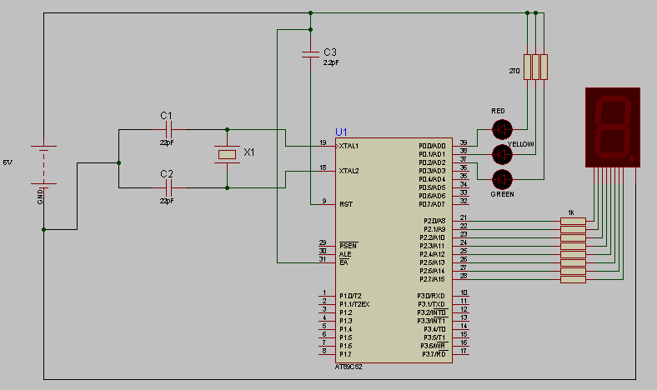

**4. Experimental Results**

**5. Conclusion**

After the interfacing of Seven segment to 8051 microcontroller the traffic light controller was implemented. The three LED’s (red, yellow and green) indicated output of a traffic controller. The seven segment displayed the counter and the LED’s operate as traffic light. All three LED’s glow in an interval of 1 second.

References

|  |  |
| --- | --- |
| [1] | Atmel AT89C51 datasheet  <https://www.engineersgarage.com/electronic-components/at89c51-microcontroller-datasheet> |
| [2] | Seven segment display card user manual:-  <https://www.pantechsolutions.net/interface-cards-tutorials/user-manual-for-seven-segment-display-card> |
|  |  |
|  |  |